Angle in Solid Geometry
# Source: AI Source: Provided by: [Data Path: Persons Table -> ID Column: 1, Name_En Column: Motasem Essam] -> From: [ChatGPT] on [7/25/2026]
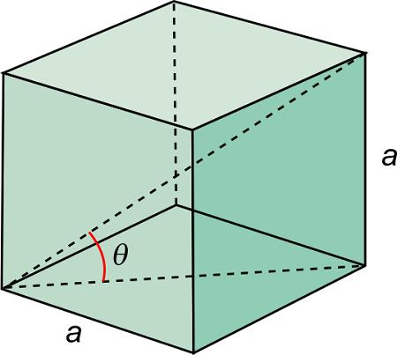
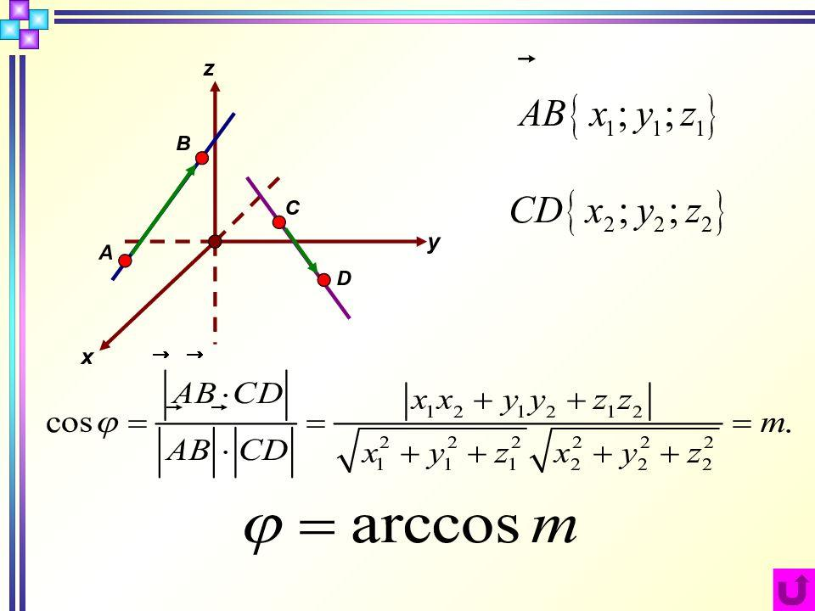
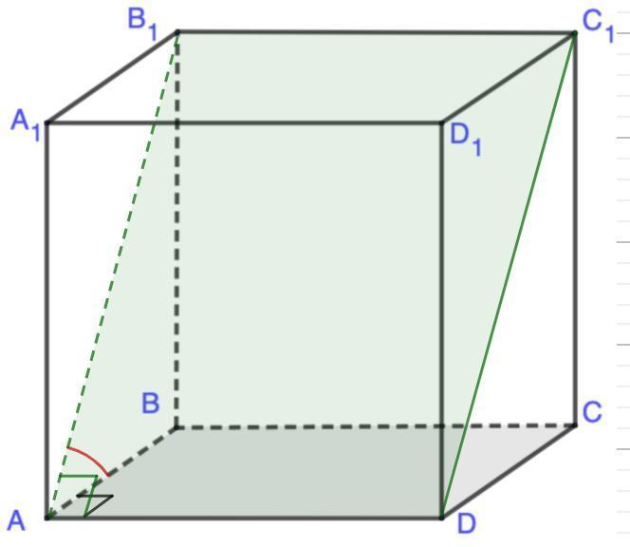

Definition
# Source: AI Source: Provided by: [Data Path: Persons Table -> ID Column: 1, Name_En Column: Motasem Essam] -> From: [ChatGPT] on [7/25/2026]
An angle in Solid Geometry is a geometric measure of the amount of rotation or separation between two intersecting lines, rays, edges, or planes in three-dimensional space.
Angles in solid geometry describe relationships between the elements of solids, including edges, faces, diagonals, and surfaces. Unlike plane geometry, where angles are studied in a single plane, solid geometry also considers angles between objects that lie in different planes.

2. Simple Definition
# Source: AI Source: Provided by: [Data Path: Persons Table -> ID Column: 1, Name_En Column: Motasem Essam] -> From: [ChatGPT] on [7/25/2026]
An angle measures how much two geometric elements turn away from or separate from each other.
For example, two adjacent edges of a cube meet at a right angle of ${90}^{∘}$.

Key Characteristics
# Source: AI Source: Provided by: [Data Path: Persons Table -> ID Column: 1, Name_En Column: Motasem Essam] -> From: [ChatGPT] on [7/25/2026]
- Angular measure: Describes the separation or orientation of geometric elements.
- Measured in degrees or radians: Common units are degrees $\left(∘\right)$ and radians.
- Defined by geometric elements: An angle may be formed by two rays, two lines, two intersecting planes, or a combination of a line and a plane.
- Three-dimensional relationships: Some angles describe relationships that cannot be understood by considering only one plane.
- Vertex or intersection: A plane angle has a vertex, while a dihedral angle is associated with an edge shared by two faces.
- Calculable: Angles can be determined using geometric properties, trigonometry, or vectors.

Types of Angles in Solid Geometry

1. Plane Angle
# Source: AI Source: Provided by: [Data Path: Persons Table -> ID Column: 1, Name_En Column: Motasem Essam] -> From: [ChatGPT] on [7/25/2026]
An angle formed by two rays or line segments that lie in the same plane.
Example: Two adjacent edges of a cube form a ${90}^{∘}$ angle.
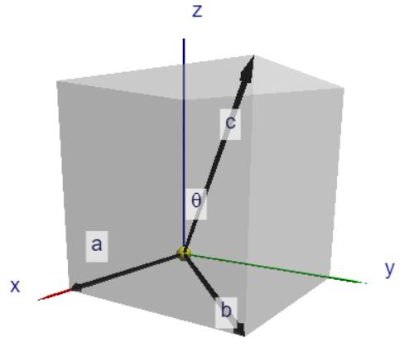

2. Angle Between Two Lines
# Source: AI Source: Provided by: [Data Path: Persons Table -> ID Column: 1, Name_En Column: Motasem Essam] -> From: [ChatGPT] on [7/25/2026]
The smaller angle between two intersecting lines, or between parallel translations of two non-intersecting lines.
Example: The angle between a cube's space diagonal and one of its edges.
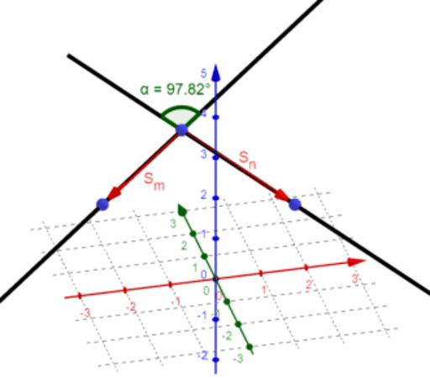

3. Angle Between a Line and a Plane
# Source: AI Source: Provided by: [Data Path: Persons Table -> ID Column: 1, Name_En Column: Motasem Essam] -> From: [ChatGPT] on [7/25/2026]
The acute angle between a line and its orthogonal projection onto a plane.
Example: The angle between a space diagonal of a cube and the plane containing its base.
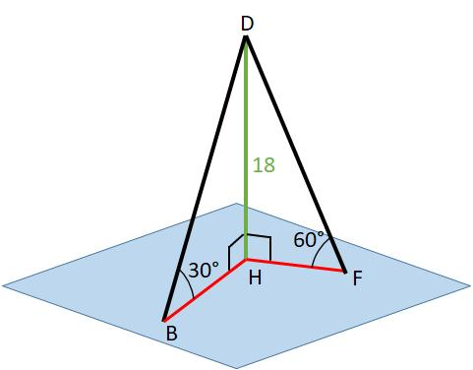

4. Dihedral Angle
# Source: AI Source: Provided by: [Data Path: Persons Table -> ID Column: 1, Name_En Column: Motasem Essam] -> From: [ChatGPT] on [7/25/2026]
The angle between two planes meeting along a common line. In a polyhedron, this line may be an edge shared by two faces.
Example: Two adjacent faces of a cube meet at a dihedral angle of ${90}^{∘}$.
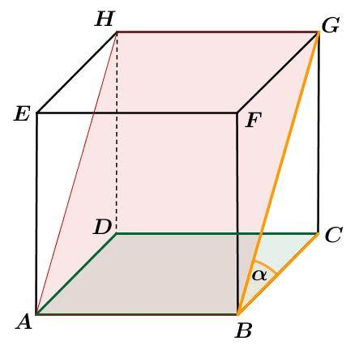

5. Solid Angle
# Source: AI Source: Provided by: [Data Path: Persons Table -> ID Column: 1, Name_En Column: Motasem Essam] -> From: [ChatGPT] on [7/25/2026]
A three-dimensional measure of how large an object or region appears from a point. It is measured in steradians.
Example: The solid angle subtended by a spherical cap when viewed from the sphere's center.
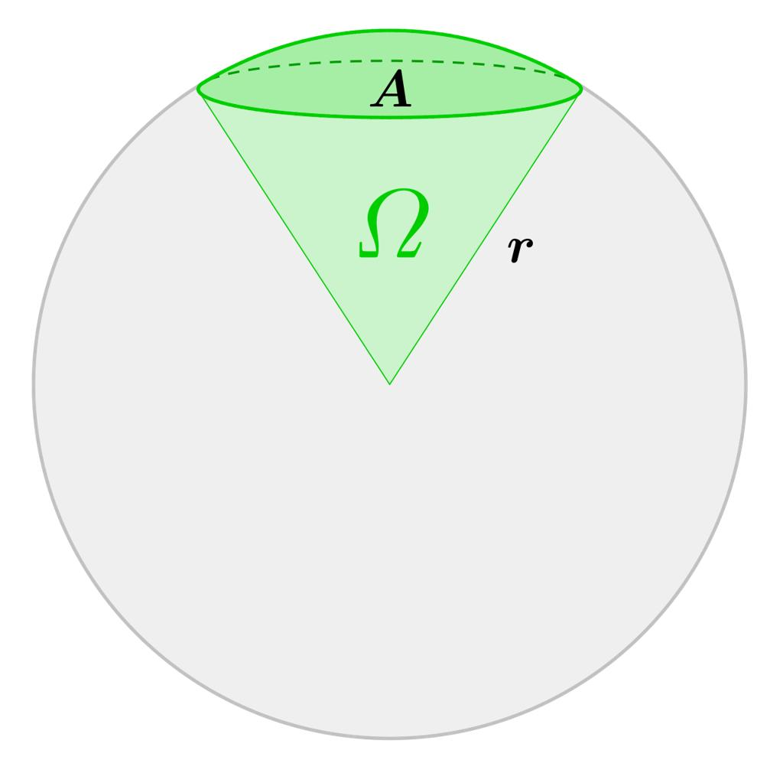

Classification by Angle Measure
# Source: AI Source: Provided by: [Data Path: Persons Table -> ID Column: 1, Name_En Column: Motasem Essam] -> From: [ChatGPT] on [7/25/2026]
Plane angles encountered in solid geometry can also be classified by their measure.
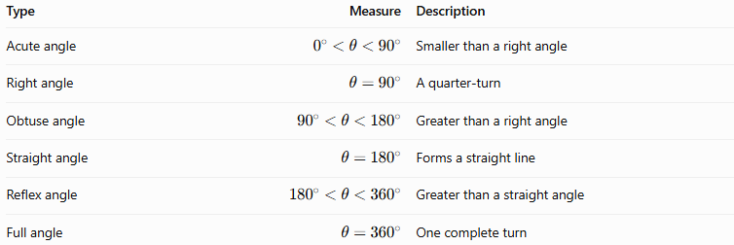
Type | Measure | Description
Acute angle | $$0^{∘}<θ<{90}^{∘}$$ | Smaller than a right angle
Right angle | $$θ={90}^{∘}$$ | A quarter-turn
Obtuse angle | $${90}^{∘}<θ<{180}^{∘}$$ | Greater than a right angle
Straight angle | $$θ={180}^{∘}$$ | Forms a straight line
Reflex angle | $${180}^{∘}<θ<{360}^{∘}$$ | Greater than a straight angle
Full angle | $$θ={360}^{∘}$$ | One complete turn
These classifications apply to ordinary directed or undirected plane angles as appropriate; angles between two lines and between two planes are often conventionally reported using the smaller angle from $0^{∘}$ to ${90}^{∘}$.

Fundamental Formulas

1. Angle Between Two Vectors
# Source: AI Source: Provided by: [Data Path: Persons Table -> ID Column: 1, Name_En Column: Motasem Essam] -> From: [ChatGPT] on [7/25/2026]
For nonzero vectors $u$ and $v$, the angle $θ$ between them is given by
$$\boxed{\cos{θ}=\frac{u⋅v}{\left\|u\right\|\left\|v\right\|}}$$
Therefore,
$$\boxed{θ=\cos^{-1}\left(\frac{u⋅v}{\left\|u\right\|\left\|v\right\|}\right)}$$
The dot product is
$$u⋅v=u_{x}v_{x}+u_{y}v_{y}+u_{z}v_{z}$$
This formula is useful for calculating angles between edges, diagonals, and lines in three-dimensional space.

2. Angle Between a Line and a Plane
# Source: AI Source: Provided by: [Data Path: Persons Table -> ID Column: 1, Name_En Column: Motasem Essam] -> From: [ChatGPT] on [7/25/2026]
Let $d$ be a nonzero direction vector of the line and $n$ a nonzero normal vector to the plane. The acute angle $α$ between the line and plane satisfies
$$\boxed{\sin{α}=\frac{\left|d⋅n\right|}{\left\|d\right\|\left\|n\right\|}}$$
- If $α=0^{∘}$, the line is parallel to the plane or lies within it.
- If $α={90}^{∘}$, the line is perpendicular to the plane.

3. Dihedral Angle
# Source: AI Source: Provided by: [Data Path: Persons Table -> ID Column: 1, Name_En Column: Motasem Essam] -> From: [ChatGPT] on [7/25/2026]
For two intersecting planes with normal vectors $n_{1}$ and $n_{2}$, the smaller angle $ϕ$ between their normals satisfies
$$\cos{ϕ}=\frac{\left|n_{1}⋅n_{2}\right|}{\left\|n_{1}\right\|\left\|n_{2}\right\|}$$
The smaller angle between the planes is
$$\boxed{θ=ϕ}$$
where $θ$ lies between $0^{∘}$ and ${90}^{∘}$. For a particular interior dihedral angle of a polyhedron, the angle may instead be the supplementary angle, depending on the orientation and which side of the faces is considered.

4. Solid Angle
# Source: AI Source: Provided by: [Data Path: Persons Table -> ID Column: 1, Name_En Column: Motasem Essam] -> From: [ChatGPT] on [7/25/2026]
A solid angle $Ω$ is measured in steradians (sr). For a sphere of radius $r$, a surface patch with area $A$ subtends a solid angle at the center of
$$\boxed{Ω=\frac{A}{r^{2}}}$$
For a complete sphere, the total solid angle is
$$\boxed{Ω=4π\text{ sr}}$$

Example: Angles in a Cube
# Source: AI Source: Provided by: [Data Path: Persons Table -> ID Column: 1, Name_En Column: Motasem Essam] -> From: [ChatGPT] on [7/25/2026]
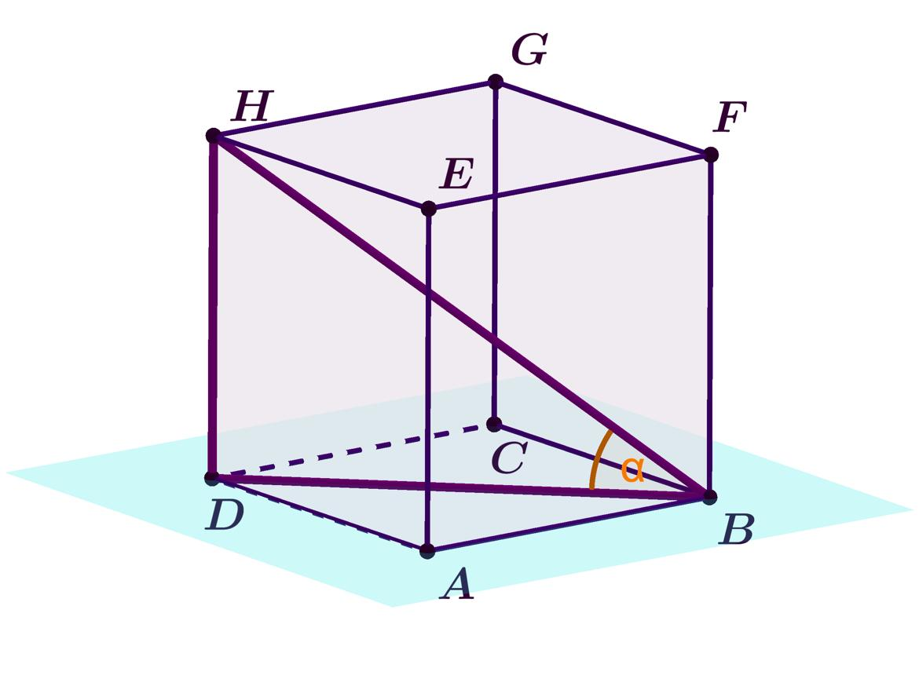
Consider a cube with side length $a$.
Angle between adjacent edges
Adjacent edges meet at a right angle:
$$\boxed{{90}^{∘}}$$
Angle between a space diagonal and an edge
A space diagonal has direction vector $\left(a,a,a\right)$, while an edge from the same vertex may have direction vector $\left(a,0,0\right)$.
Using the dot-product formula,
$$\cos{θ}=\frac{a^{2}}{a\sqrt{3a^{2}}}=\frac{1}{\sqrt{3}}$$
Thus,
$$\boxed{θ=\cos^{-1}\left(\frac{1}{\sqrt{3}}\right)≈{54.74}^{∘}}$$
Angle between a space diagonal and the base plane
The height of the cube is $a$, and the diagonal of its square base is $a\sqrt{2}$. Therefore,
$$\tan{α}=\frac{a}{a\sqrt{2}}=\frac{1}{\sqrt{2}}$$
So,
$$\boxed{α≈{35.26}^{∘}}$$

Angle vs. Related Geometric Concepts
# Source: AI Source: Provided by: [Data Path: Persons Table -> ID Column: 1, Name_En Column: Motasem Essam] -> From: [ChatGPT] on [7/25/2026]
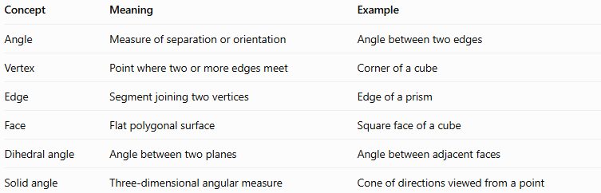
Concept | Meaning | Example
Angle | Measure of separation or orientation | Angle between two edges
Vertex | Point where two or more edges meet | Corner of a cube
Edge | Segment joining two vertices | Edge of a prism
Face | Flat polygonal surface | Square face of a cube
Dihedral angle | Angle between two planes | Angle between adjacent faces
Solid angle | Three-dimensional angular measure | Cone of directions viewed from a point

Applications
# Source: AI Source: Provided by: [Data Path: Persons Table -> ID Column: 1, Name_En Column: Motasem Essam] -> From: [ChatGPT] on [7/25/2026]
- Geometry: Studying relationships among edges, faces, and diagonals.
- Architecture: Designing corners, roof slopes, and intersecting surfaces.
- Engineering: Determining the orientation of components in three-dimensional assemblies.
- Computer graphics: Calculating object orientations, surface normals, and lighting.
- Physics: Describing fields, radiation, and the apparent size of objects using solid angles.
- Navigation and robotics: Calculating directions and angles between spatial paths.

Key Points
# Source: AI Source: Provided by: [Data Path: Persons Table -> ID Column: 1, Name_En Column: Motasem Essam] -> From: [ChatGPT] on [7/25/2026]
- Angles in solid geometry describe relationships between geometric elements in three dimensions.
- Plane angles are measured in degrees or radians.
- The angle between two lines can be calculated using direction vectors.
- The angle between a line and a plane is defined using the line's direction and its projection onto the plane.
- A dihedral angle describes the relationship between two planes.
- A solid angle measures a three-dimensional spread of directions and is measured in steradians.
- The angle between a cube's space diagonal and an edge from the same vertex is approximately \(54.74^\circ\).

Conclusion
# Source: AI Source: Provided by: [Data Path: Persons Table -> ID Column: 1, Name_En Column: Motasem Essam] -> From: [ChatGPT] on [7/25/2026]
An angle in Solid Geometry is an essential measure for describing the orientation and separation of lines, edges, faces, and planes in three-dimensional space. Plane angles describe local corners, dihedral angles describe how faces meet, and solid angles describe the spread of directions around a point. These concepts are fundamental to analyzing solids, solving spatial geometry problems, and understanding three-dimensional structures.

